Wren’s Nursery
Forest
School
Handbook

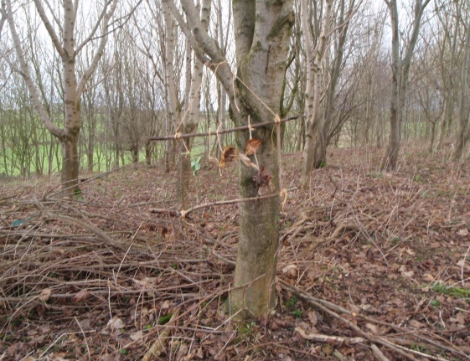
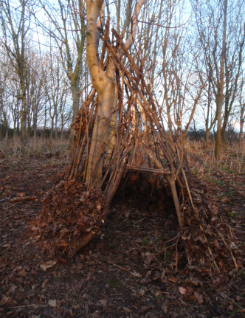
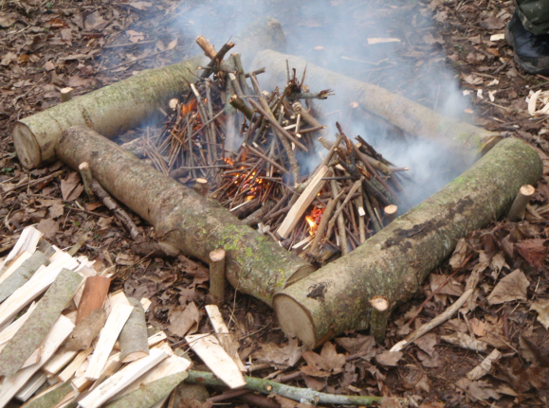

Forest School Ethos
Forest School, held in an outdoor environment, provides children with outdoor learning experiences which support all aspects of the curriculum and particularly strengthens children’s social, emotional and physical development. Through careful observations and evaluations of the children the tasks and activities will be set with each individual in mind in order to progress them according to their own needs and interests. They will be provided with opportunities to explore, find their own limitations, make sensible choices in relation to risk, in addition to developing practical skills such as knot tying, using tools and construction. Each activity will challenge the children but will set each of them up to succeed to raise their confidence and self esteem. As a result the children will develop their independence and skills which will support them throughout their lives.
Code of Conduct

- At least one member of staff will hold a Paediatric First Aid Certificate.

- Permission slips signed by parents/ carers must be obtained for each child that participates in Forest School sessions involving the use of tools and fires. This is part of the Nursery Enrolment Form pack.

- All Wren’s Nursery Policies will be implemented and adhered to throughout each and every session held in the grounds. These are available within the nursery and on the nursery website www.wrensnursery.co.uk.

- This document and all associated policies will be updated when required and reviewed annually.

- In accordance with nursery policy, photographs of children will only be taken if there is written consent from parents.

- Strategies for behaviour management and anti-bullying procedures will be in accordance with the nursery policies.

Forest School Site
- Whenever the children leave the nursery and enter the grounds a ‘Forest School Ethos’ will be applied.

- The outdoor sessions will be held in all areas of Hooke Court grounds. Each site will be accessed by foot.

- Boundaries will be clearly explained to all supporting staff and the children upon arrival at the site. Children wishing to explore the site will be accompanied by an adult who will keep the child/ children in their vision.

- Children will be taught to use all outdoor areas with respect. At the end of each programme the site should be returned to its original state.
- All constructions and creations will be taken down at the end of a Forest School programme.
- Imported items will be removed after each session.
- All litter will be removed after each session.
- Children will not remove materials from living plants unless this is specified in the Forest School Leader plans and supervised by an adult.

Eating and Drinking
- Prevent children eating anything that they find in the outdoor environment by talking with them and warning them of the dangers.
- Remind children to avoid placing their hands in their mouths.
- When drinks and snacks are consumed during an Outdoor session the children will clean their hands with antibacterial wipes or gel.
- All food that is cooked on a campfire will be cooked on a sterile toasting fork made with willow.
- On some occasions food will be cooked on the fire with the grill over. In these circumstances the Forest School Leader will be responsible for all cooking and handling of the food. At all times the Fire Procedures will be followed.

Toileting
- All children will be taken to the toilet prior to a Forest School session.
- Toilets are accessible at the Aelfric hall if needed.
- If necessary children may toilet outside, with the support of an adult, in an area designated, if they feel comfortable to do so. The member of staff supporting the child will ensure that they make the rest of the team aware.

Moving, Transporting and Playing with Woodland Materials
- Children may carry sticks as long as their arms. If they wish to transport larger items they should be taught to drag, carry in pairs, roll or use rope to pull them. Safe lifting techniques should be modelled by all adults by bending the knees and keeping the back straight.

- The children will use natural materials in their activities. At any point an activity that a child has initiated is deemed unsafe they will be spoken to by an adult who will encourage them to assess the risk of their activity and find a solution to making an activity safer or moving to a new activity if it is felt necessary.

- Ensure children are considering others in their activities, making sure that they do not endanger others.

- Children benefit from challenging climbing activities and should be allowed to climb trees. They will be supported at a 1:1 ratio during this activity. The adult should check the ground for sharp materials and the tree for rotten branches. The child should not climb out of arms reach of the adult who should be there to assist if the child becomes stuck or is at risk of falling.

- Children enjoy digging activities. Designated areas will be available for digging and the children will be taught to fill in their holes once they have finished their activity.

Equipment and Emergency Bag

The Forest School Leader will be responsible for ensuring that all essential items are kept safely in an Emergency Bag which is taken to every Forest School session. The emergency bag will contain the following items:

- First Aid Kit
- Mobile phone
- Any medication for individuals

Other items may include:
- Hand wipes
- Nappy sacks and tissues
- Burns kit
- Sun cream
- Spare clothing

* In accordance with our confidentiality policy all documents containing details of children will be stored in the locked filing cabinet in the Nursery.
Daily Operating Procedure

Prior to the Session

- The senior member of staff all assisting staff on the lesson plans, children involved and risk assessments.
- The senior member of staff will check the emergency equipment bag and any other resources to be used within the session.
- The senior member of staff will take a register of the children prior to the session.

During the Session

- The senior member of staff and assisting staff will continue to risk assess activities on an ongoing basis throughout the session.
- All staff will headcount the children to ensure that they are all accounted for.

After the Session

- The senior member of staff will conduct a headcount of staff and children before leaving the site.
- The senior member of staff and staff will ensure that the children walk back to the nursery safely.
- The senior member of staff will check all tools following the tool use and maintenance procedures.

Tool Use and Storage Procedure

The decision to introduce tools into a Forest School session will be made by the Forest School Leader. Tool use will be planned into sessions but if the leader deems that it is not a safe time then tools will not be introduced.

- Tools are kept in storage bags and containers to which the children will not have access.
- All tools are counted out and in of the storage containers and bags.
- All tools are used for a specific purpose. Their correct use and transportation will be modelled by adults at all times.
- Tools will only be used in designated areas which will be a safe distance from active children.
- Tools may only be transported by walking, never running.
- Gloves must never be worn when using tools.
- All tools that are damaged will be clearly marked and secured using black electrical tape and removed from use for repair or disposal.
- Ensure that tools are dry before storing them.
- All tools should be stored in a locked cupboard.
- All bladed tools must be maintained to ensure they are sharp.

Potato Peelers
Potato peelers are used to sharpen and whittle sticks. They should be used with a 1:2 ratio.
- Check that the blade is held firmly onto the handle.
- Check that the blade is clean and free from rust and debri.
- Kneel on one knee supporting the arm holding the wood on the bent upright knee and holding the tool in the dominant hand.
- Peel away from the body at all times.
- Potato peelers should be carried blade down with the arm held to the side.

Axe
Axes are used to split wood and shape wood to a point for pegs and poles. They should be used with a 1:1 ratio.
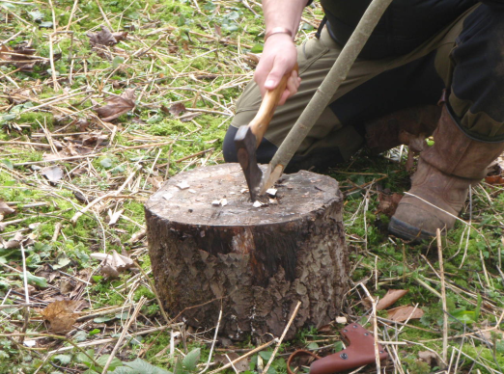
- Remove the axe carefully from the bag.
- Check that the axe head is firmly attached to the handle with no movement.
- Carefully remove the axe cover and visually check the blade for damage or debri.
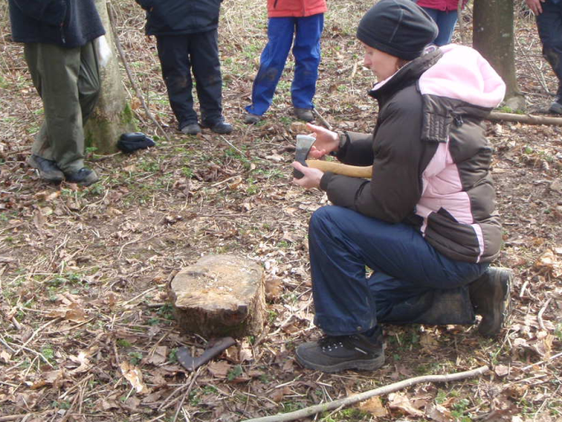
- Hold the axe in your non-dominant hand with the axe head held firmly in the hand and the handle along the forearm. Using the thumb of your dominant hand run the thumb across the blade (never along the length of the blade) to check for sharpness.
- Use a large wood block to support the wood to be axed.
- Ensure that any observers are to the side and not at the front or behind the tool user. They must be a safe distance away from the tool when it is in use.
- Ensure that the wood to be axed is a suitable length to ensure that the non-dominant hand holding the wood is a safe distance from the axe.
- Holding the wood firmly use the axe in a downward motion to shape the wood.
- To safely store the tool temporarily if you need to pause during use cut the axe head firmly into the log block. To remove the axe push the handle down first then lift the axe to remove it from the block.
- Axes should be carried with the cover on, axe handle in the hand close to the head and the arm held to the side.
- After use ensure that the axe is clean and free from debri. Place the axe cover over the head and return to its storage container.

Bow Saw
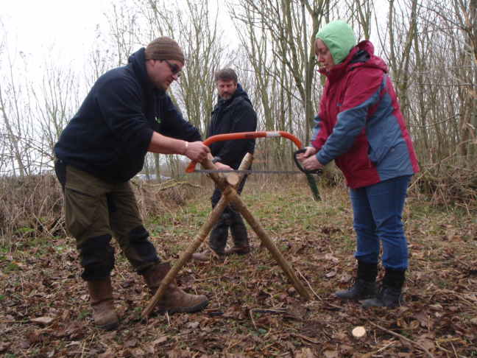
Bow saws are used to cut wood larger than an 3cm in diameter. Bow saws are used on a 1:1 ratio in a buddy pair with adult. There are two types of bow saw blade:
- Raker tooth – used for cutting fresh (green) wood
- Peg tooth – for cutting old wood

- Remove the saw from the storage container.
- Visually check the saw for damage.
- Check that the blade is firmly attached to the saw with no movement or rattling and that the nuts and bolts are secure.
- Carefully remove the blade cover and visually check the blade for debri or dust.
- Test for sharpness by doing a test cut.
- Use an A-Frame to support the wood to be cut with helpers holding the opposite end.
- Place the non-dominant hand on the wood behind the A-Frame.
- Using the saw in the dominant hand pull the saw along the wood towards the body to create an indent into the wood. Repeat this three times.
- Continue to saw forwards and back.
- Upon completing sawing place the blade cover back onto the blade.
- Carry the bow saw by the frame with the blade pointing downwards and the arm held by the side.
- Maintain the bow saw by spraying oil such as WD40 and wiping with a paintbrush.

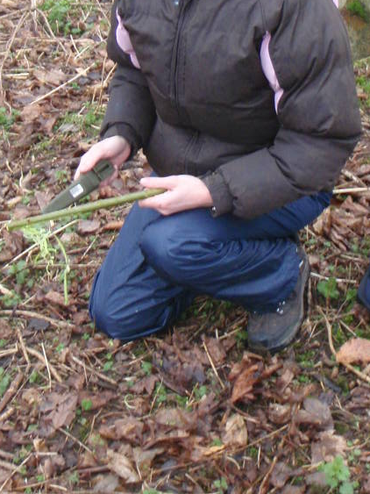
Fixed Blade Knife
Fixed blade knifes may be used to whittle and shape wood. Fixed blade knifes are to be used by adults only.

- Remove the knife from the locked storage container and visually check it with the sheath on.
- In the designated area kneel on one knee.
- Check the knife blade is securely attached to the handle.
- Remove the blade from the sheath holding the sheath in the non-dominant hand.
- Visually check the blade for damage and debri.
- Hold the knife in the non-dominant hand by the handle with the blade facing up, resting the arm on the upright knee. Check the blade for sharpness by running the thumb of the dominant hand across the blade (never along the length of the blade).
- Use the knife in this stance, holding the knife in the dominant hand and the wood in the non-dominant arm supported by the knee. Always cut away from the body.
- Carefully remove any swathe from the knife by wiping carefully with a cloth.
- Place the knife back in the sheath ensuring the blade is sitting in the grooves.
- Transport the knife by holding it downwards with the arm held by the side.
- Maintain the blade by cleaning with oil and a cloth and sharpening it using a knife sharpener.

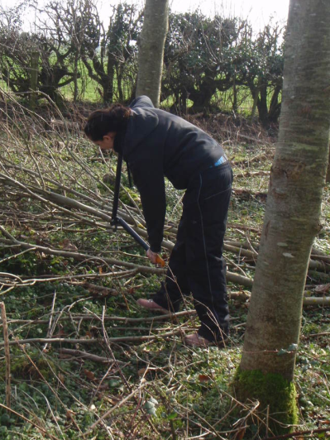
Loppers
Loppers are used to cut wood less than 5cm in diameter. They should be used to cut wood below shoulder level. They should be used with a 1:1 ratio.

- Remove the loppers from the storage bag and carry out a visual check.
- Ensure that the arms of the loppers move freely and do not feel loose.
- Open the loppers and place one arm against the shoulder and the other arm opened downwards and held against the leg. Visually check the blade for signs of damage and debri. Using the thumb of your dominant hand run it across, never along the blade, to check for sharpness.
- Use the loppers below shoulder height ensuring all hands are well away from the blades.
- Carry the loppers horizontal to the ground with blade facing downwards.
- Maintain the loppers by removing any debri using a light oil and a cloth.

Secateurs
Secateurs perform the same job as the loppers but should be used on wood approximately 1-2cm in diameter.

- Visually check the secateurs ensuring that there are no signs of damage.
- Unfasten the safety clip and ensure that the arms are secure.
- Place the secateurs with a log between the handles and visually check the blades before running the thumb of the dominant hand across the blade, never along, to check sharpness.
- Cut wood by placing between the blades over the wood to be cut and squeezing the hands.
- After use secure the secateurs by the safety clip and placing them back into the storage bag.
- Maintain the tool by cleaning the blade with a light oil and cloth.

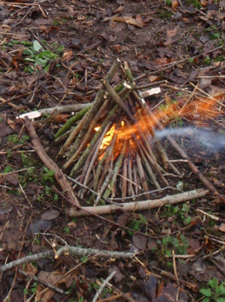
Fire Lighting and Fire Safety

The decision to introduce fire into a Forest School session will be made by the Forest School Leader. The use of fire will be planned into sessions but if the leader deems that it is not a safe time then fire will not be introduced.

- Before lighting a fire the Forest School Leader will consider:
- Are the children behaving appropriately.
- Is the fire positioned in a safe place which will not allow the fire to spread or set light to anything overhanging the area.
- Is the appropriate safety equipment in place:
Water in watering can
First aid equipment
- Is there enough fuel for the length of time you wish the fire to burn for collected ready.

- A permanent fire surround has been constructed within the site. Seating logs placed no closer than 1.5m around the fire surround. Children move to and from the fire by stepping over from behind the logs and leaving in the same manner. There is strictly no moving within the fire circle. There is no running within five metres of the fire.

- All safety equipment is kept in the designated Fire Safety area within close reach if required. Safety equipment includes a fire blanket and full watering can.

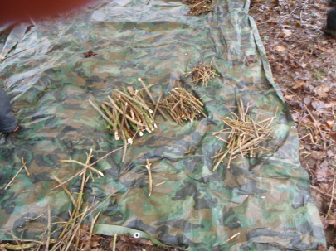
- Children will collect the materials for the fire collecting three sizes of sticks:
- Matchstick size
- Thumb size
- Pencil size

- The Forest School Leader will construct and light the fire. The fire will never be left unattended.
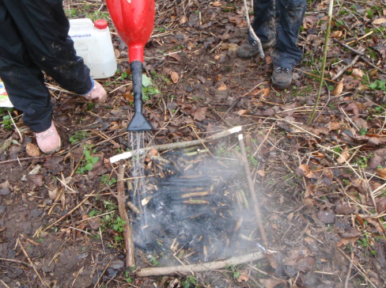
- The fire will be put out by the Forest School Leader by spreading the ashes and pouring water from the watering can over the embers. Check the fire is out by holding the back of the hand over the embers to check for heat.

Health and Safety at Forest School
Wren’s Nursery have a comprehensive Safeguarding Policy which describes in detail the great importance we place on ensuring each child’s, member of staff and visitor’s safety and well being. This policy can be accessed on the nursery website. The following list relates to additional health and safety measures that are taken during outdoor sessions.
.

- Every adult assisting the understands that they have a responsibility to take all reasonable measures to safeguard each child participating in outdoor activities.

- The senior member of staff will always carry an Emergency Bag which will contain all of the essential items listed in the Emergency Bag section of this document.

- In an emergency the senior member of staff will be responsible for contacting the office who will call for the emergency services. If the office staff are unavailable for any reason the senior member of staff will phone the emergency services directly.

- The senior member of staff will be responsible for conducting a visual risk assessment of the site upon arrival and ongoing risk assessments during each activity.

- Tools and equipment will only be used in the ways specified in the ‘Use and Storage of Tools’ section.

Risk Assessment
Risks are assessed using the following process:
- Look and identify potential hazards.
- Consider who might be harmed and how.
- Evaluate whether the existing safety precautions are suitable or whether additional measures need to be implemented.
- Record all findings on the appropriate Risk Assessment forms.
- Review and update all risk assessments as necessary.
- Inform all assisting adults of the identified risks for each session.

Accident and Emergency Procedures

In the event of an emergency during a an outdoor session the senior member of staff will maintain control of the whole group. Other adults will be required to assist and the senior member of staff will delegate responsibility as necessary and appropriate according to the situation. When dealing with an emergency the senior member of staff will implement the following strategy (these steps may not necessarily be covered in the exact sequence outlined below):

- Assess the extent of the emergency as quickly as possible.
- Ensure that other members of the group are adequately supervised and safe from immediate harm.
- Inform assisting adults to contact the office to alert the emergency services and next of kin passing on the details of the casualties.
- Carry out all appropriate first aid.
- Ensure that an appropriate adult accompanies the casualty to hospital.
- The adult must be DBS checked
- Inform the office of the details of the incident as soon as possible.
- The office will report all of these details to the next of kin.
- The office will contact the police if necessary.
- Record the details of the incident including all relevant facts, witness details and preserve any vital evidence.
- Copies will be retained by the Directors.
- Keep a written account of all times, events and contacts after the incident.
- Copies will be retained by the Directors.
- Complete an accident report form as soon as possible. Contact HSE (RIDDOR).

At no point should any member of the group speak about the details of the incident to the media. The names and details of those involved will remain confidential due to the distress that they or their families may endure. Any journalists must be referred to the Directors. Neither should legal liability in relation to the accident or incident be discussed with external parties without informing the Directors.

Other Emergency Incidents

Lost or Missing Child
- Make an immediate search of the area
- Ensure the safety of the rest of the group and keep them together.
- Alert the office.
- Follow the nursery procedure for lost and missing children
- All available adults to search.
- Contact the police.
- Contact the next of kin.

Uninvited Persons
- Challenge the intruder and politely ask them to leave.
- Remove all children from the area.
- Inform the office as soon as possible about the incident.
- The office will contact the police and their advice will be followed.
- Inform all parents of the incident.

Adverse Weather Conditions
- If the weather conditions are deemed unsafe the senior member of staff will postpone or cancel the outdoor session.
- In the event that the weather changes during a session to an extent that the senior member of staff feels that it is unsafe the children will be removed to a safe area back in the nursery.

Behavioural Problems
- All trained staff will implement positive behaviour strategies to maintain a safe environment.
- If a situation with a child is escalating staff may use time out strategies and attempt to calm the child.
- If necessary, the rest of the group will be removed from any potential risk. An assistant will be asked by the senior member of staff to contact the office to send assistance. All relevant nursery policies will be adhered to at all points.
- When the situation has calmed down the child will be spoken with and parents informed if necessary.
- The incident will be recorded in the Nursery Incident Record.

Equal Opportunities
Wren’s Nursery have a full and comprehensive Equal Opportunities policy showing our commitment to equal and fair opportunities for all children, members of staff and visitors. This policy will be implemented and adhered to for all outdoor sessions.
Where children have additional needs, these will be assessed and the appropriate measures and strategies implemented to ensure that our practise is as inclusive as possible and all children have access to outdoor sessions.
It is very important for all parents and carers to understand that their child/children need to be suitably equipped with the correct clothing and footwear they need to participate in outdoor activities in all weather conditions. In addition, we would like to make parents aware that the children will take part in activities and games that involve a certain amount of mud and mess. We encourage carefully calculated risk taking under the close supervision of adults in order to let the children explore the environment and their own limitations. The children will be encouraged to work cooperatively with all members of the group regardless of whether or not they normally work or play together to strengthen their communication and team working skills. Our activities are carefully planned to ‘set every child up to succeed’ raising self esteem and confidence. Each and every child has the same entitlement to these experiences and our wonderful outdoor environment.

Child Protection
Wren’s Nursery have a full and comprehensive Child Protection Policy and each member of staff has received Child Protection Training. This policy and training will be applied to all outdoor sessions.
It is important to note that all adults working in outdoor sessions must be aware that children may become more confident, feel secure and develop risk taking whilst being outdoors. In these circumstances they may be more likely to make a disclosure about a child protection issue. In these circumstances the following points from the Child Protection Policy must always be followed:
- Never promise to keep a disclosure a secret.
- Listen to the child but never ask leading questions.
- Comfort the child as necessary.
- Inform the Child Protection Officer or the Deputy Child Protection Officer as soon as possible after the event.
- As soon as possible make a detailed written report on the disclosure.
In the event that an allegation is made against a member of staff the Nursery Allegations policy will be implemented.

Reviewed Feb 2025

